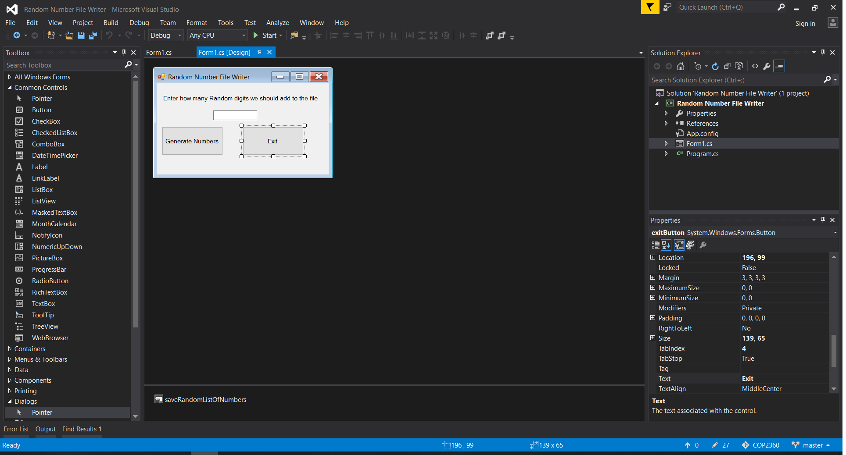

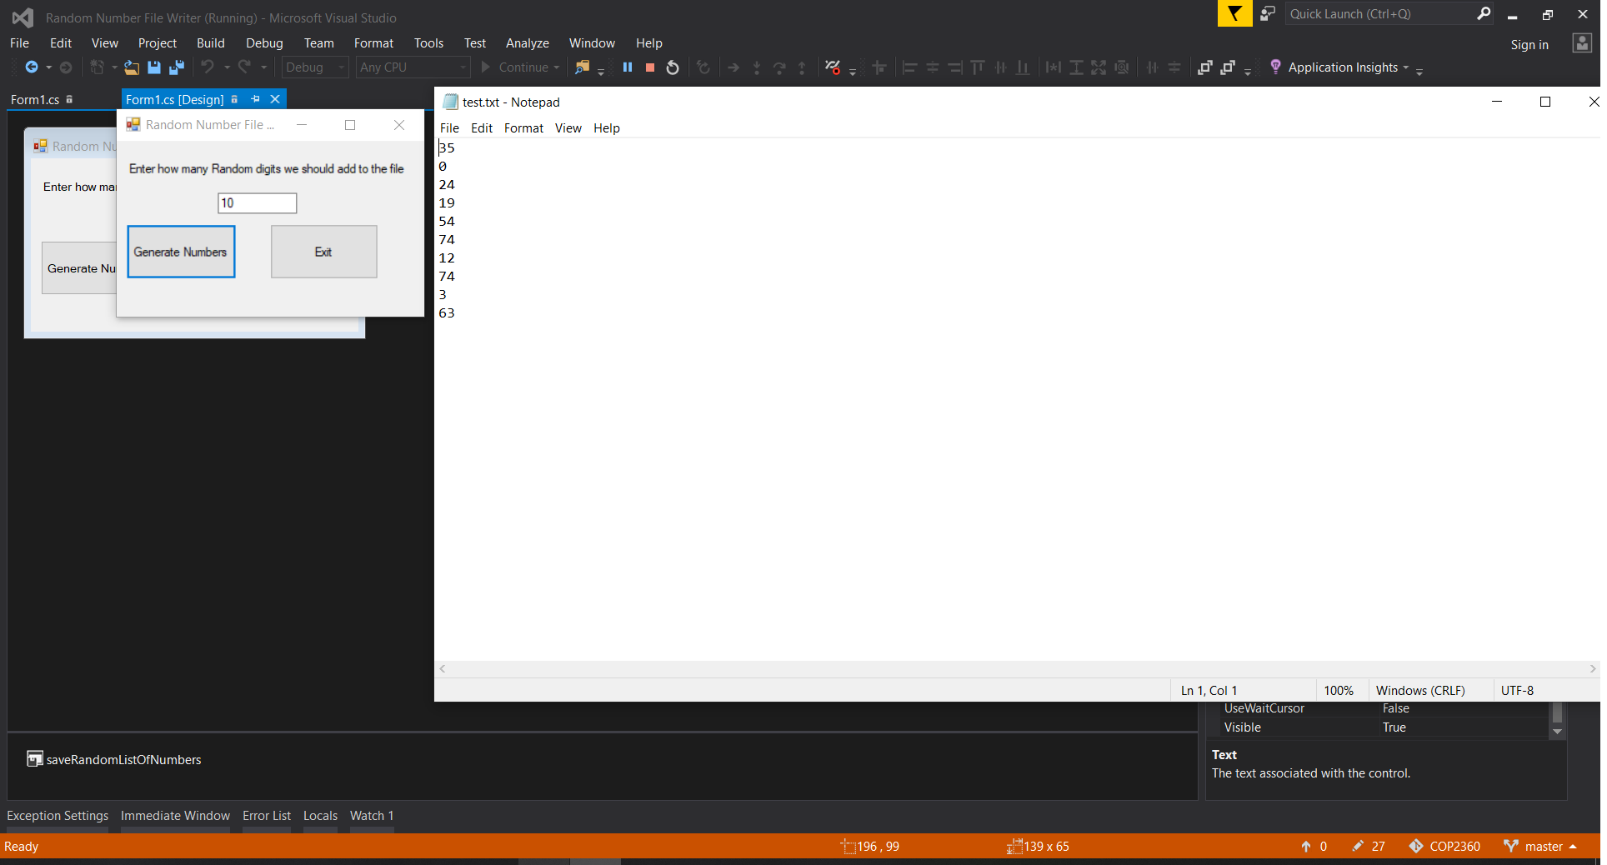using System;

using System.Collections.Generic;

using System.ComponentModel;

using System.Data;

using System.Drawing;

using System.Linq;

using System.Text;

using System.Threading.Tasks;

using System.Windows.Forms;

using System.IO;

namespace Random_Number_File_Writer

{

public partial class randomFileWriterForm : Form

{

public randomFileWriterForm()

{

InitializeComponent();

}

private void exitButton_Click(object sender, EventArgs e)

{

this.Close();

}

private void generateRandomNumsButton_Click(object sender, EventArgs e)

{

int qtyRandomNums;

//declare the streamwriter

StreamWriter outputFile;

//specify the initial path for the save button

saveRandomListOfNumbers.InitialDirectory = @"C:\\";

saveRandomListOfNumbers.Filter = "txt files (*.txt)|*.txt|All files (*.*)|*.*";

saveRandomListOfNumbers.DefaultExt = ".txt";

saveRandomListOfNumbers.CheckPathExists = true;

try

{

//get the amount of random numbers from the user

if (int.TryParse(numInputTextBox.Text, out qtyRandomNums))

{

// I nearly saved twice. this seems more AND less intuitive to have

// a function call in the if statement but it worked

if (saveRandomListOfNumbers.ShowDialog() == DialogResult.OK)

{

//I had this outside the showDialog if statement. I was enraged for over an hour

outputFile = File.CreateText(saveRandomListOfNumbers.FileName);

//create random Object

Random rand = new Random();

// use a for loop to generate the requisite amoutn of random #s

for (int counter=0; counter < qtyRandomNums; counter++)

{

//create a random number from 0-100 and push it to the list

int randomNumber = rand.Next(101);

outputFile.WriteLine(randomNumber.ToString());

}

outputFile.Close();

MessageBox.Show("Save Successful!");

}

else

{

MessageBox.Show("Save Cancelled");

}

}

else

{

//invalid input from the user

MessageBox.Show("try entering an integer this time. Thank you");

numInputTextBox.Text = "";

numInputTextBox.Focus();

}

}

catch (Exception ex)

{

MessageBox.Show(ex.Message);

}

}

}

}